BRITISH BURN ASSOCIATION
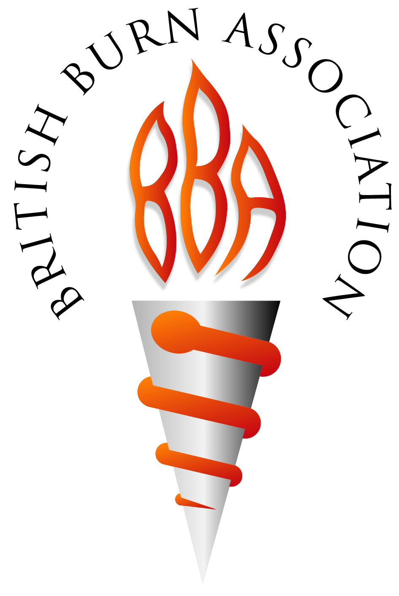
British Burn Association
35-43 Lincolns’ Inn Fields
London, WC2A 3PE

T: 020 7869 6923
F: 020 7869 6929

E: info@britishburnassociation.org
www.britishburnassociation.org

BURNS THERAPY SPECIAL INTEREST GROUP MEETING

Novosorb® BTM in Acute Burns and Burn Reconstruction and the Development of Therapy Pathways

Thursday 4th July 2024
10am-3pm
Pendigo Suite, Resorts World Arena, Birmingham

BBA members may attend free of charge. Non-members may attend their first meeting for free, but subsequent meetings require non-members to join the BBA or pay a nominal fee of £5 for meeting attendance

Please complete and return the attached registration form to janine.evans@wales.nhs.uk

